Dropdown

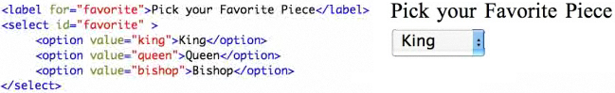

**Clear combo**

var dropDown = document.getElementById("favorite");

dropDown.selectedIndex = 0;

**Append**

for (var i=0; i < month.length;++i){

addOption(**ddl_ID**, month[i], month[i]);  
}

function addOption(ddl_ID,text,value )

{

var ddl = documents.GetELementById("ddl_ID");

var optn = document.createElement("OPTION");

optn.text = text;

optn.value = value;

ddl.options.add(optn);

}

Call javascript with

string combo = “<select id=“favorite”>”;

combo = combo + “ <option value=’king’>King</option>”;

combo = combo + “ <option value=’queen’>Queen</option>”;

combo = combo+ “ </selected>”;

Si agrega

string combo = “<var ddl = document.getElementById("favorite"); “;

combo = combo + “ ddlselectedIndex = 0; “;

combo = combo + “ addOption(**ddl**, 1, ‘First’); “;

combo = combo + “ addOption(**ddl**, 2, ‘Second’); “;

Page.ClientScript.RegisterStartupScript(GetType(), "msgbox", combo, true);

Pero si se da dentro de un UpdatePanel

ScriptManager.RegisterStartupScript(this, GetType(), "alert", combo, true);